Power BI ASSIGNMENT 2
DAX & DATA VISUALIZATION

NAME : SHIAM ALEX
ASSIGNMENT : E-COMMERCE SALES ANALYSIS

DAX FORMULAS
ORDER COUNT : Order Count = COUNTROWS('Order Details')

Average Profit in Delhi : Average Profit in Delhi =
CALCULATE(
AVERAGE('Order Details'[Profit]),
'List of Orders'[City] = "Delhi"
)

YTD Sales : YTD Sales =
TOTALYTD(
SUM('Order Details'[Amount]),
'List of Orders'[Order Date]
)

Category type : Category Type =
'Order Details'[Category] & " - " & 'Order Details'[Sub-Category]

Revenue per Order : Revenue per Order =
'Order Details'[Amount] * 'Order Details'[Quantity]

Sales Category : Sales Category =
IF(
'Order Details'[Amount] > AVERAGE('Order Details'[Amount]),
"Above Average",
"Below Average"
)

SALES TARGET ACHEIVEMENT BY CATOGORY

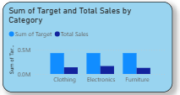

PROFIT MARGIN DONUT
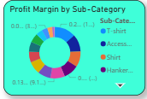

MONTHLY SALES TREND
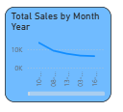

PROFIT VS QUANTITY
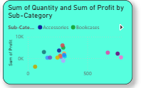

CARDS
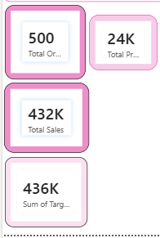
MATRIX
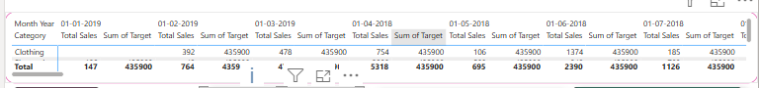

MAP
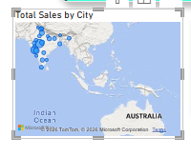
TREE MAP
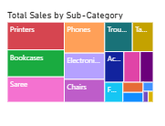
FUNNEL
